|  |  |
| --- | --- |
| Name: Sayyed Sohail Rashid | Course Name: DC-LAB |
| Class: BE-CO | Batch: 01 |
| Roll no: 18CO48 | Assignment No: 02 |

**Aim** : Case Study on Google File System(GFS).

Theory:

What is Google File System?

* Google file system is a scalable distributed file system developed by Google to provide efficient and reliable access to data using large clusters of commodity hardware.
* It is designed to meet the rapidly growing demand of Google's data processing need.
* It provides performance, scalability, reliability and availability of data across distributed System for handling and processing big data.

# Characteristics:

1. Files are organized hierarchically in directories and identified by path name.
2. It supports all the general operations on files like read, write, open, delete and so on.
3. It provides atomic append operation known as record append.
4. The concurrent writes to the same region are not serializable.
5. It performs two operations: snapshot and record append.

# Goals:

1. Performance
2. Reliability
3. Automation
4. Fault Tolerance
5. Scalability
6. Availability

# GFS Architecture:

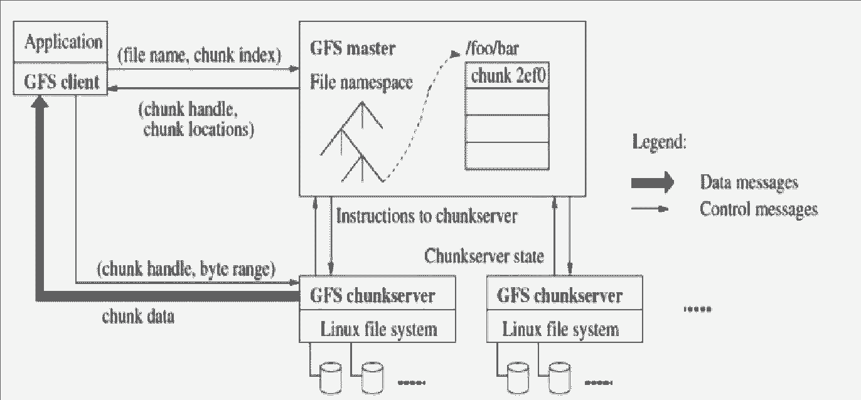

* 1. Master Node:
     + It is responsible for the activities of the system such as managing chunk leases, load balancing and so on.
     + It maintains all the file system metadata.
     + It contains an operation log that stores namespaces and files to chunk mappings.
     + It periodically communicates with chunk server to determine chunk locations and assesses state of the overall system.
     + Each node on the namespace tree has its own read-write lock to manage concurrency.
  2. Chunk and Chunk Server
     + The files are divided into fixed sized chunks.
     + Each chunk has an immutable and globally unique 64-bit chunk handle.
     + Chunk server is responsible for storing chunks on local disk as linux files.
     + By default, each chunk is replicated 3 times across multiple chunk servers.
     + The size of the chunk is 64 MB.
     + Due to such a large chunk, it results in space wastage because of internal fragmentation.
     + The advantages of large chunk size are as follows:

1. It reduces the client's need to interact with the master. It means reading or writing in a single chunk requires only one request to master.
2. It reduces network overhead by keeping a persistent TCP connection to the chunk server for multiple operations performed by clients.
3. It reduces the size of metadata stored in the master. It enables storage of metadata in memory.
   1. Client Node
      * Client node is linked with the application that implements GFS API.
      * It communicates with the master and the chunk server to read chunk server.

Operation Log and MetaData:

* + - Operation log is the persistent records of metadata.
    - It defines the logical timeline about serialized order of concurrent operations.
    - The state is recovered by the master by replaying the operation log.
    - The metadata stored in GFS master are as follows:

1. Namespace (directory hierarchy)
2. Access control information per file
3. Mapping from file to chunk
4. Current location of chunks (Chunk servers)

# Conclusion:

We have Successfully Performed the Case Study on Google File System.